Relationship Basics

- One to one relationship -> Customer table has many row and each row represent one customer. Table are may be many because customer data are big.

- One to many relationship -> Book table that has reviews column and that reviews has 1000 of reviews. Book has many reviews and reviews belong to one book.

Entity means TABLE.

- Many to many relationship -> Two entity that are Books and Authors. Books can have multiple authors and authors can belong to multiple books.

Customers have many orders, order have one customer associated with them.
One to many relationship

Customers Orders

customer_id order_id
first_name order_date
last_name amount
email customer_id

Table look like this

Table1:
Customer_id first_name last_name email
1 Blue short blue@gmail.com

Table2:

Order_id order_date amount customer_id
1 24/06/2004 26.61 1
2 06/08/2006 99.99 1

Customer_id and order_is are primary keys. They are the primary way of referring to rows in this table.

Foreign Key

References to another table within a given table. Ex: customer id is a foreign key because it is referring to this ID of the customers.

code

- CREATE TABLE customers (
- id INT PRIMARY KEY AUTO_INCREMENT,
- first_name VARCHAR(50),
- last_name VARCHAR(50),
- email VARCHAR(50)
- );

- CREATE TABLE orders (
- id INT PRIMARY KEY AUTO_INCREMENT,
- order_date DATE,
- amount DECIMAL(8,2),
- customer_id INT,
- FOREIGN KEY (customer_id) REFERENCES customers(id)
- );

- INSERT INTO customers (first_name, last_name, email)
- VALUES ('Boy', 'George', 'george@gmail.com'),
- ('George', 'Michael', 'gm@gmail.com'),
- ('David', 'Bowie', 'david@gmail.com'),
- ('Blue', 'Steele', 'blue@gmail.com'),
- ('Bette', 'Davis', 'bette@aol.com');

- INSERT INTO orders (order_date, amount, customer_id)
- VALUES ('2016-02-10', 99.99, 1),
- ('2017-11-11', 35.50, 1),
- ('2014-12-12', 800.67, 2),
- ('2015-01-03', 12.50, 2),
- ('1999-04-11', 450.25, 5);

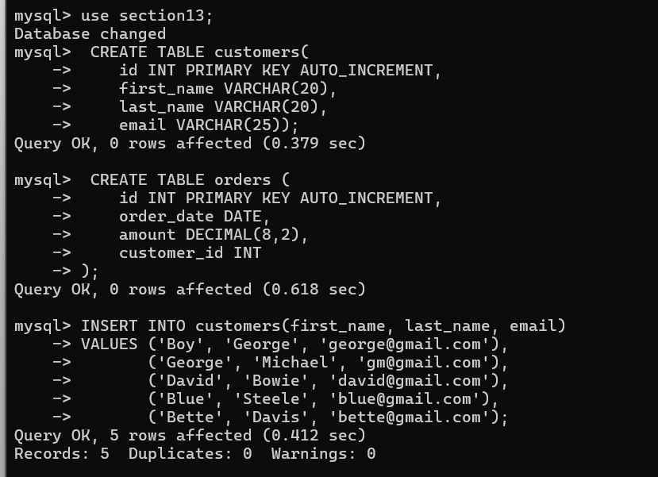

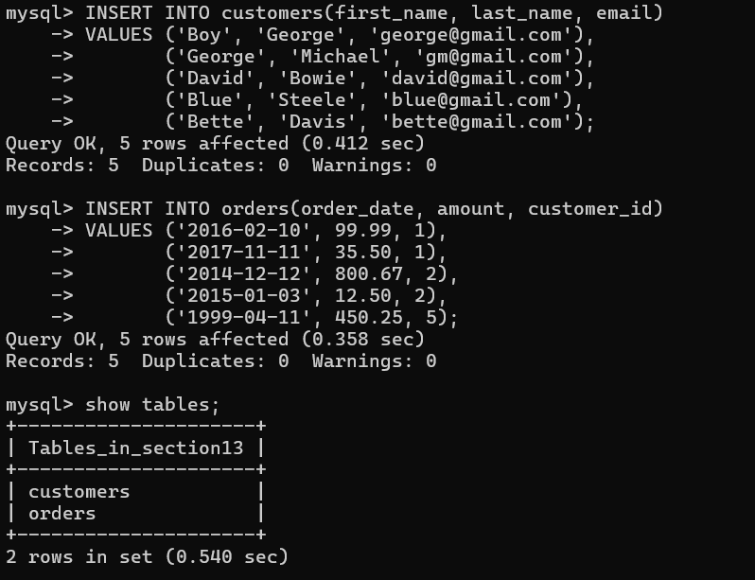

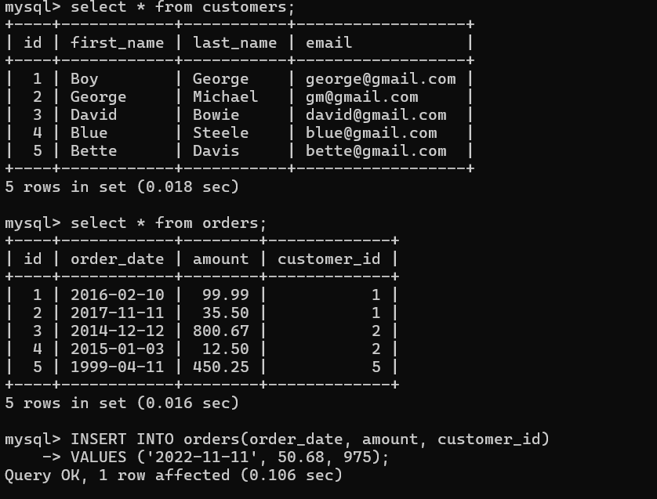

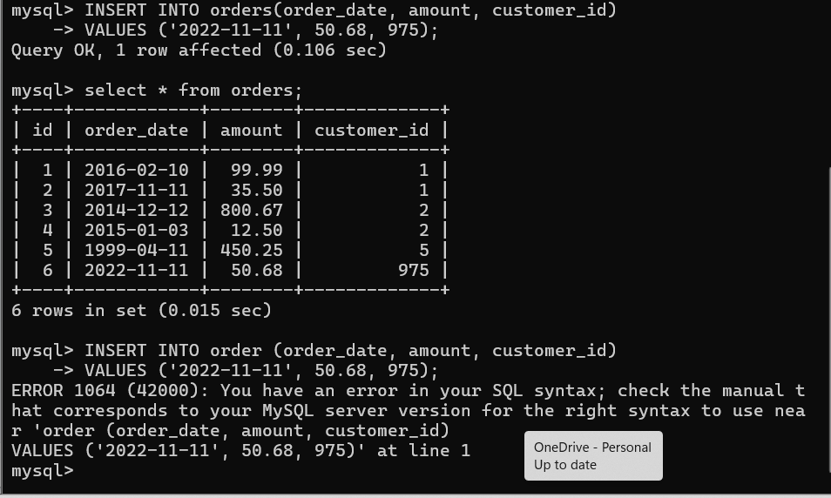

We don’t use foreign key, add duplicate customer so it is not real.
Use foreign key that is supposed to be linked to a real customer.

Table with foreign key

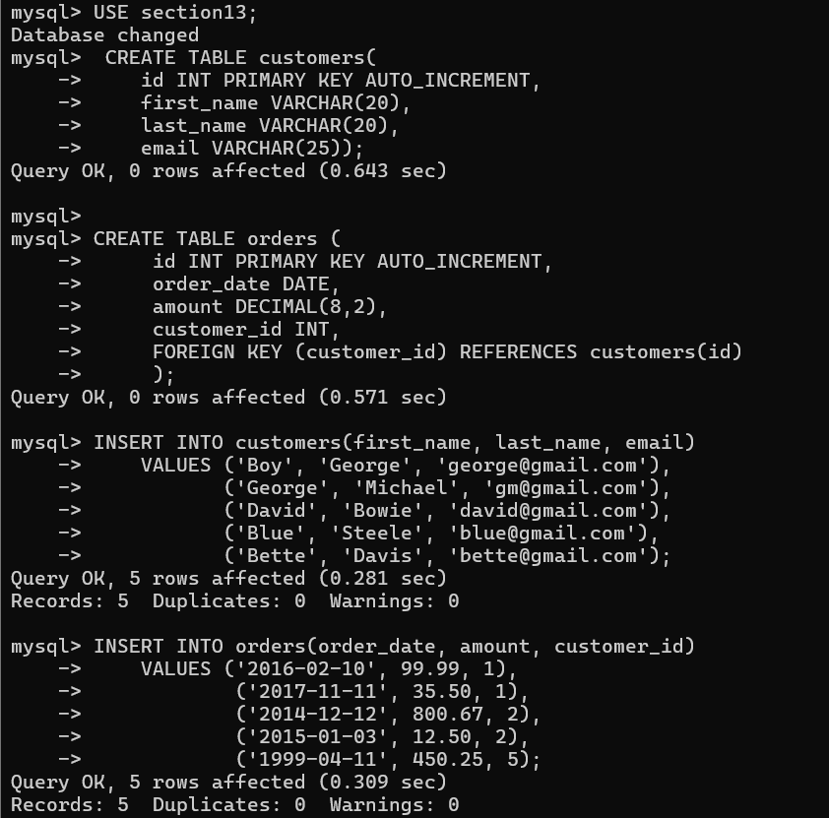

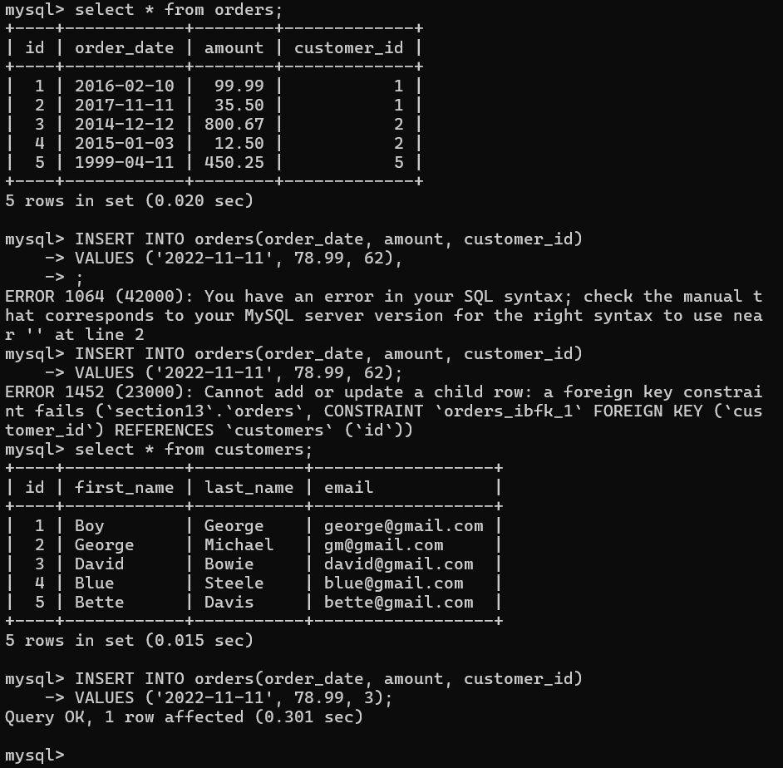

CROSS JOINS

- SELECT id FROM customers WHERE last_name = 'George';
- SELECT * FROM orders WHERE customer_id = 1;

- SELECT * FROM orders
- WHERE customer_id = (SELECT id FROM customers WHERE last_name = 'George');

- -- To perform a (kind of useless) cross join:
- SELECT * FROM customers, orders;

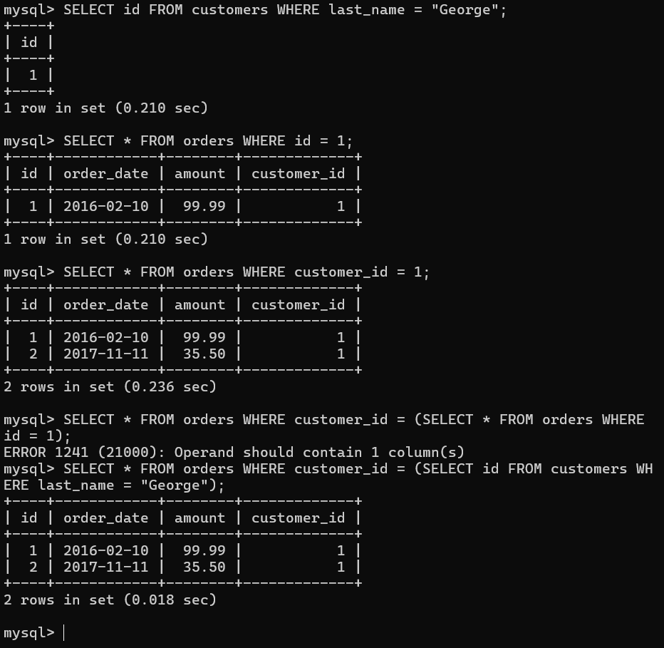

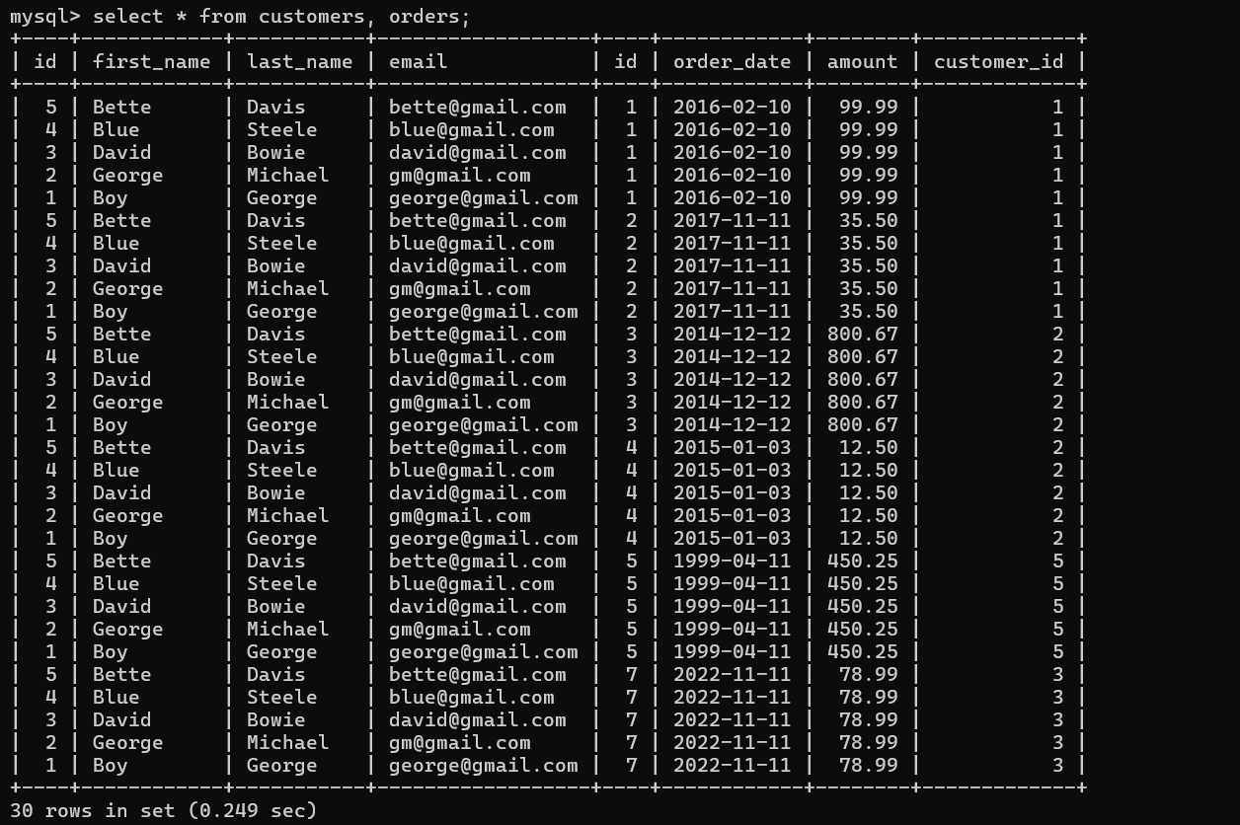

INNER JOIN

=> Inner Join means Select all records from A and B where the join condition is met.

- -- Our first inner join!
- SELECT * FROM customers
- JOIN orders ON orders.customer_id = customers.id;

- SELECT first_name, last_name, order_date, amount FROM customers
- JOIN orders ON orders.customer_id = customers.id;

- -- The order doesn't matter here:
- SELECT * FROM orders
- JOIN customers ON customers.id = orders.customer_id;

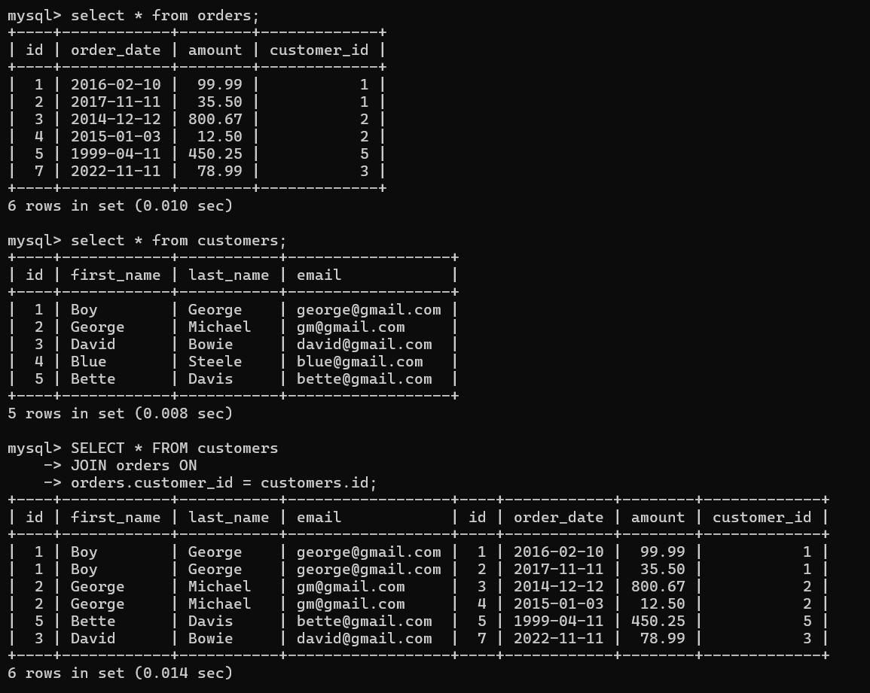

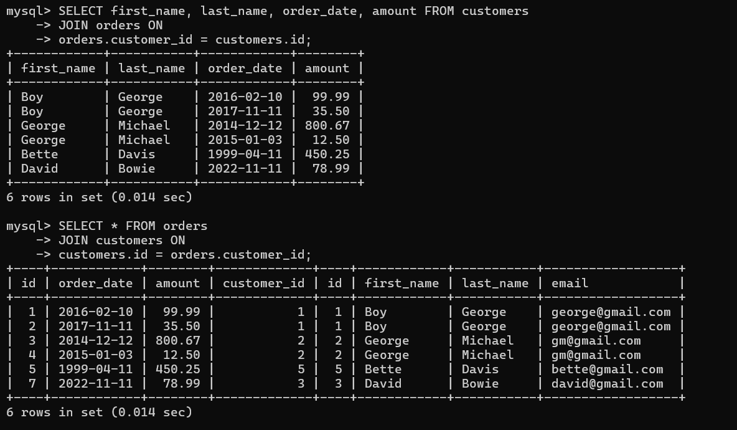

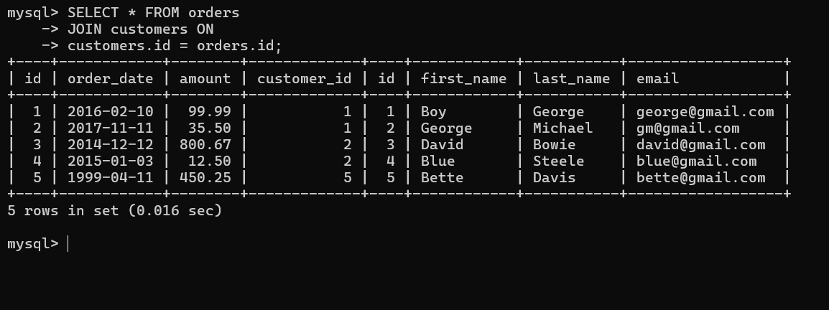

INNER JOIN WITH GROUP BY

CODE:

- SELECT
- first_name, last_name, SUM(amount) AS total
- FROM
- customers
- JOIN
- orders ON orders.customer_id = customers.id
- GROUP BY first_name , last_name
- ORDER BY total;

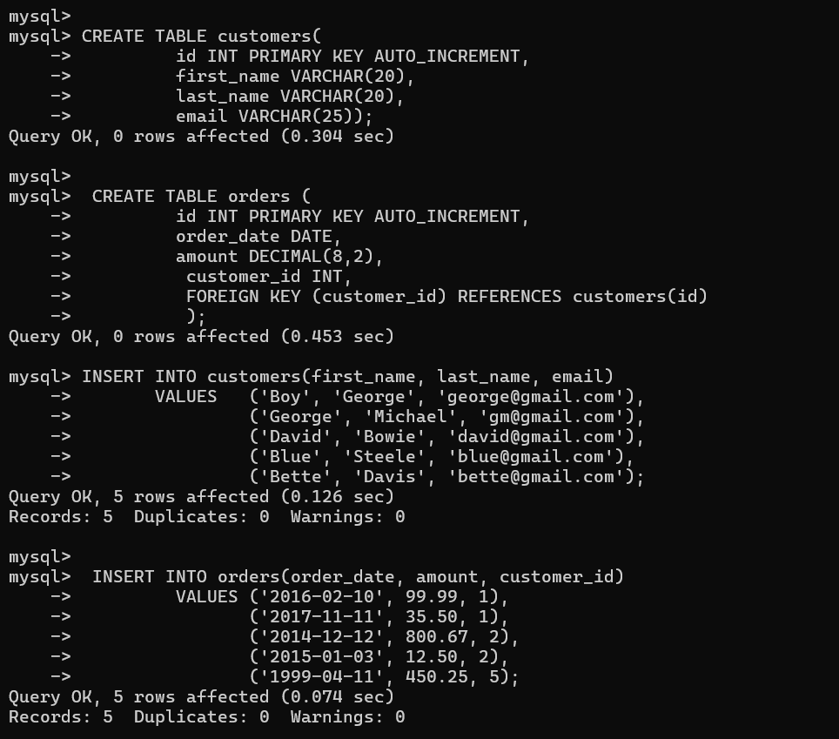

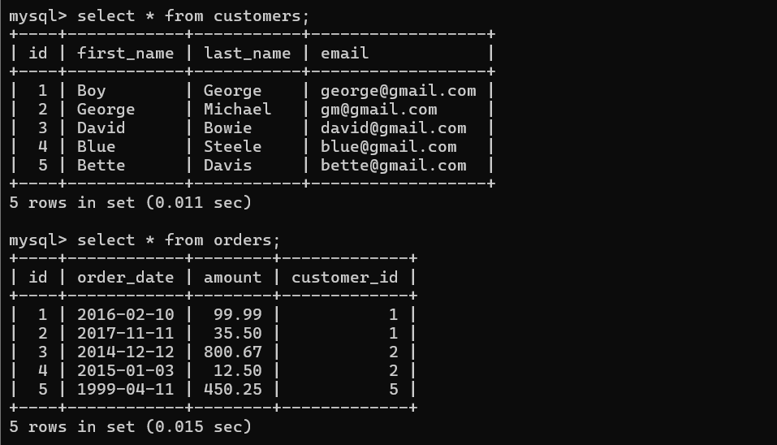

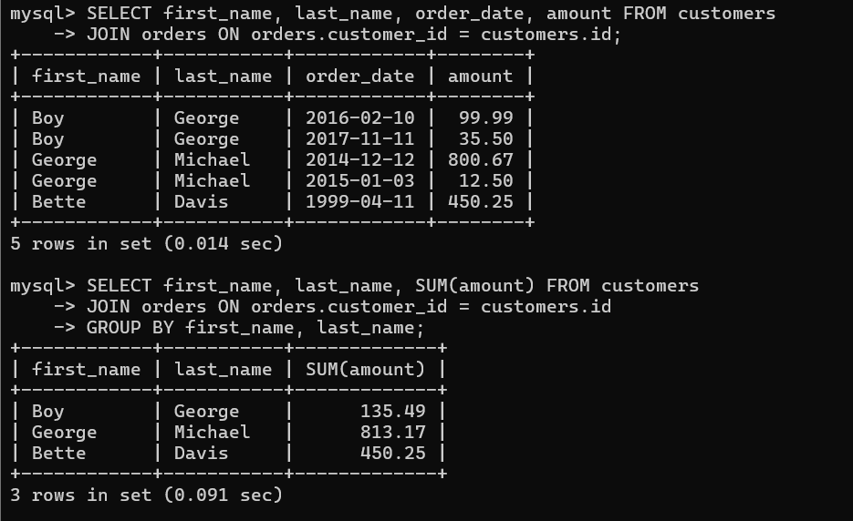

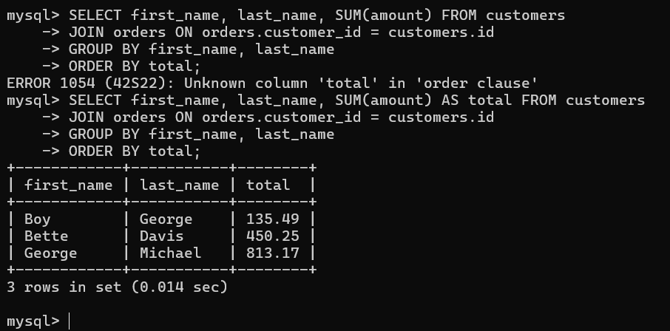

LEFT JOIN

Select everything from A, along with any of join which is the left join.

- SELECT
- first_name, last_name, order_date, amount
- FROM
- customers
- LEFT JOIN
- orders ON orders.customer_id = customers.id;

- SELECT
- order_date, amount, first_name, last_name
- FROM
- orders
- LEFT JOIN
- customers ON orders.customer_id = customers.id;

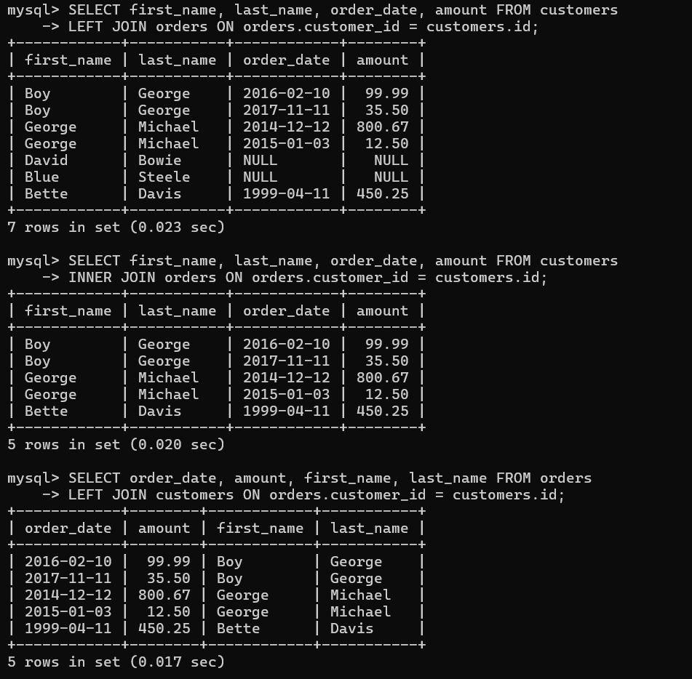

|->it takes all values from the left side table and also based on the right side table.

LEFT JOIN WITH GROUPBY

CODE

- SELECT
- first_name,
- last_name,
- IFNULL(SUM(amount), 0) AS money_spent
- FROM
- customers
- LEFT JOIN
- orders ON customers.id = orders.customer_id
- GROUP BY first_name , last_name;

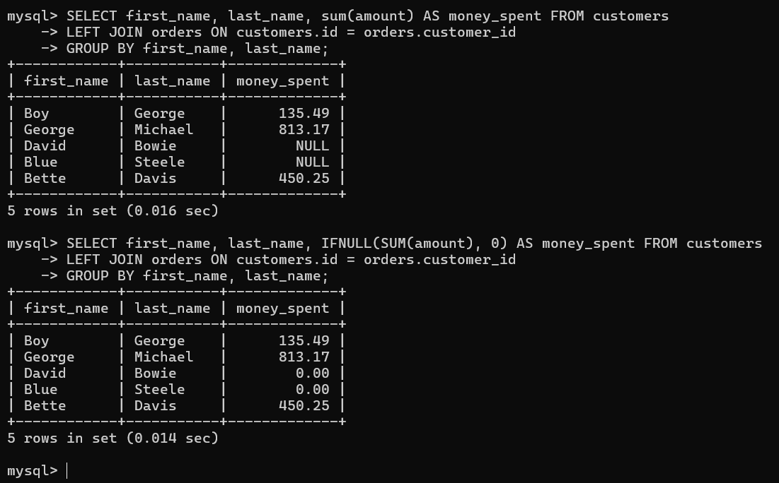

RIGHT JOIN

Select everything from B, along with any matches record in A.

CODE

- SELECT
- first_name, last_name, order_date, amount
- FROM
- customers
- RIGHT JOIN
- orders ON customers.id = orders.customer_id;

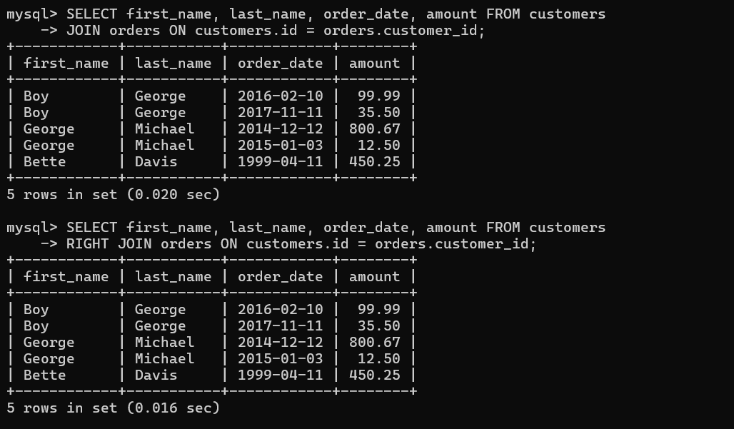

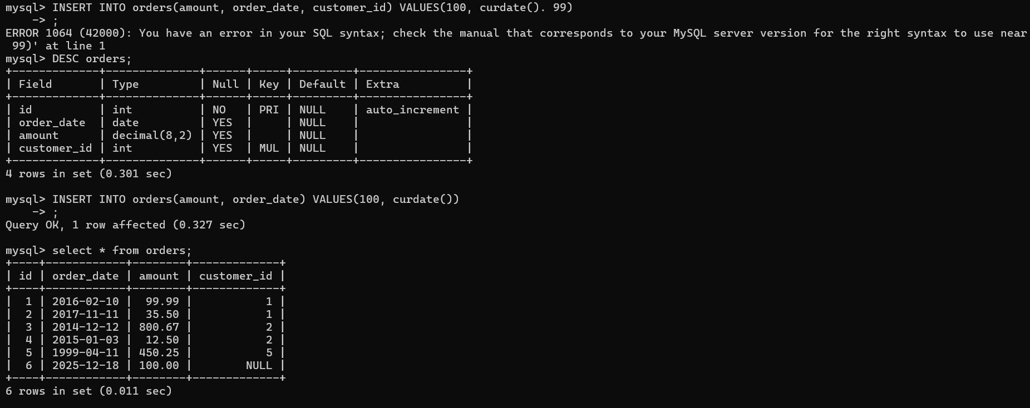

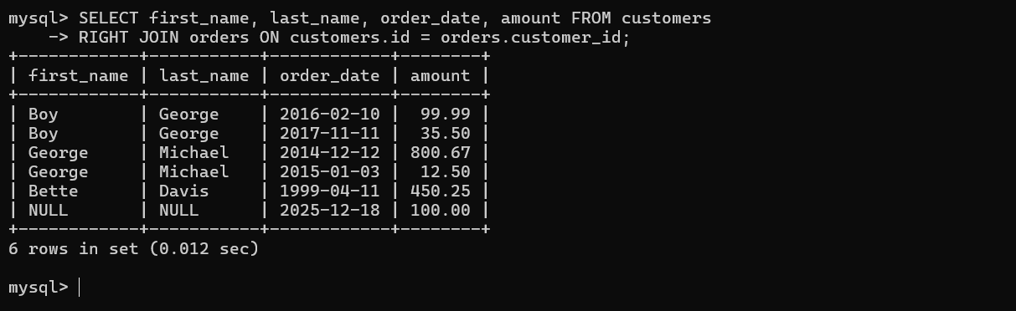

On Delete Casecase

ODC MEANS DELETE CASECADE is used for delete a row. Usual delete statement does not work because customer table is connected to the orders table. so we use the delete cascade command.

CODE

- CREATE TABLE customers (
- id INT PRIMARY KEY AUTO_INCREMENT,
- first_name VARCHAR(50),
- last_name VARCHAR(50),
- email VARCHAR(50)
- );

- CREATE TABLE orders (
- id INT PRIMARY KEY AUTO_INCREMENT,
- order_date DATE,
- amount DECIMAL(8 , 2 ),
- customer_id INT,
- FOREIGN KEY (customer_id)
- REFERENCES customers (id)
- ON DELETE CASCADE
- );

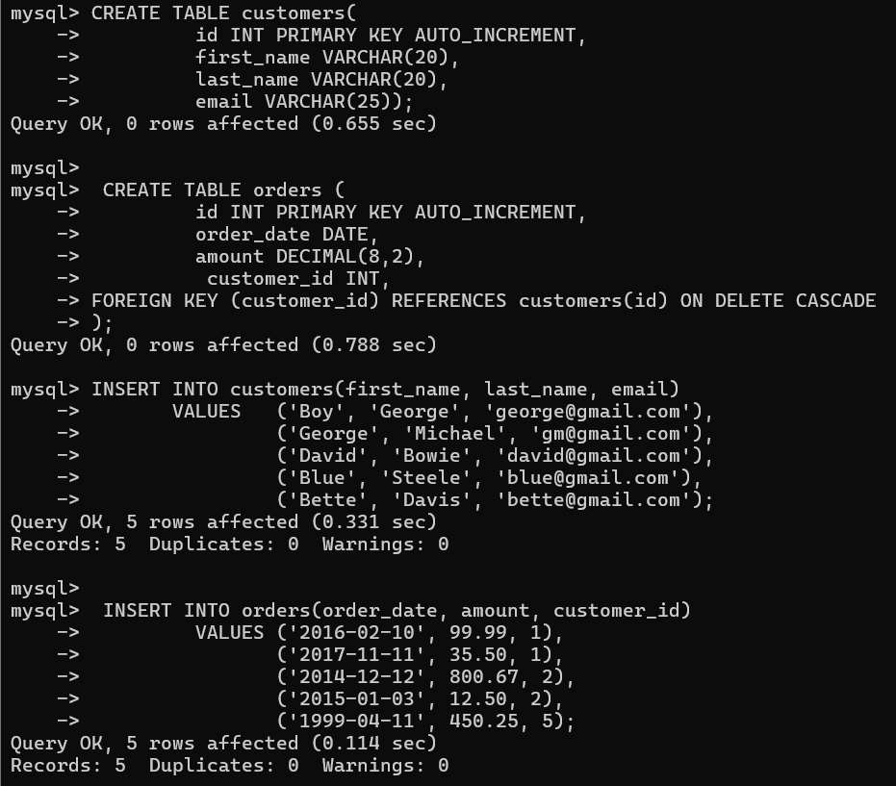

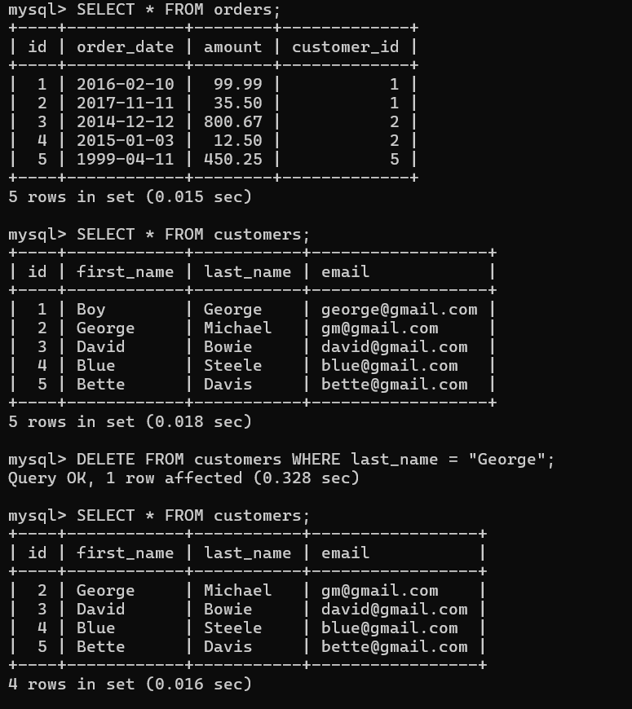

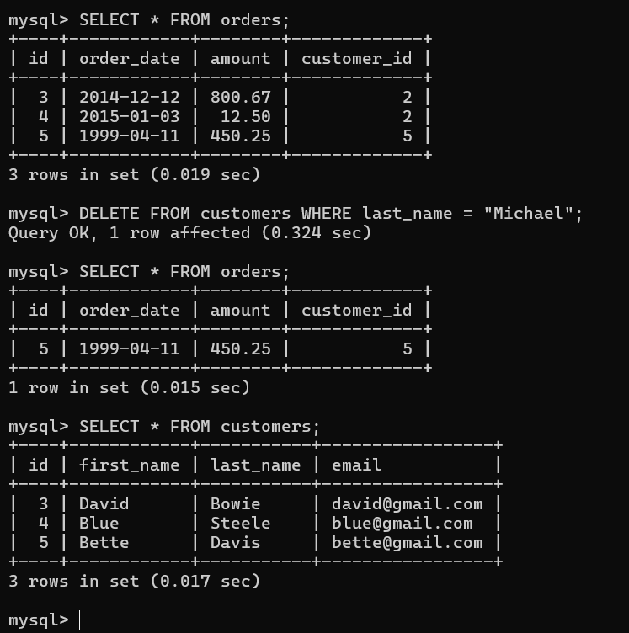

Exercise

- CREATE TABLE students (
- id INT PRIMARY KEY AUTO_INCREMENT,
- first_name VARCHAR(50)
- );

- CREATE TABLE papers (
- title VARCHAR(50),
- grade INT,
- student_id INT,
- FOREIGN KEY (student_id)
- REFERENCES students (id)
- );

- SELECT
- first_name, title, grade
- FROM
- students
- JOIN
- papers ON papers.student_id = students.id
- ORDER BY grade DESC;

- SELECT
- first_name, title, grade
- FROM
- students
- LEFT JOIN
- papers ON papers.student_id = students.id;

- SELECT
- first_name, IFNULL(title, 'MISSING'), IFNULL(grade, 0)
- FROM
- students
- LEFT JOIN
- papers ON papers.student_id = students.id;

- SELECT
- first_name, IFNULL(AVG(grade), 0) AS average
- FROM
- students
- LEFT JOIN
- papers ON students.id = papers.student_id
- GROUP BY first_name
- ORDER BY average DESC;

- SELECT
- first_name,
- IFNULL(AVG(grade), 0) AS average,
- CASE
- WHEN IFNULL(AVG(grade), 0) >= 75 THEN 'passing'
- ELSE 'failing'
- END AS passing_status
- FROM
- students
- LEFT JOIN
- papers ON students.id = papers.student_id
- GROUP BY first_name
- ORDER BY average DESC;



